CN Project

Part 1:
Reorder:
Subnet description | VLAN ID | VLAN Name | Required Number of Hosts | Network Address/CIDR | First Usable Host Address | Last  Usable Host Address | Broadcast Address
 | VLAN 35 (S) |  | 61 | 10.0.0.0 /26 | 10.0.0.1 /26 | 10.0.0.62 /26 | 10.0.0.63 /26
 | VLAN 15 (Main) |  | 31 | 10.0.0.64 /26 | 10.0.0.65 /26 | 10.0.0.126 /26 | 10.0.0.127 /26
 | VLAN 45 (N) |  | 30 | 10.0.0.128 /27 | 10.0.0.129 /27 | 10.0.0.158 /27 | 10.0.0.159 /27
 | VLAN 5 (Main) |  | 25 | 10.0.0.160 /27 | 10.0.0.161 /27 | 10.0.0.190 /27 | 10.0.0.191 /27
 | VLAN 65 (R) |  | 20 | 10.0.0.192 /27 | 10.0.0.193 /27 | 10.0.0.222 /27 | 10.0.0.223 /27
 | VLAN 130 (S) |  | 12 | 10.0.0.224 /28 | 10.0.0.225 /28 | 10.0.0.238 /28 | 10.0.0.239 /28
 | VLAN 55 (N) |  | 12 | 10.0.0.240 /28 | 10.0.0.241 /28 | 10.0.0.254 /28 | 10.0.0.255 /28
 | VLAN 75 (R) |  | 7 | 10.0.1.0 /28 | 10.0.1.1 /28 | 10.0.1.14 /28 | 10.0.1.15 /28
 | SW-S to MIU-MIU-GW |  | 7 | 10.0.1.16 /28 | 10.0.1.17 /28 | 10.0.1.30 /28 | 10.0.1.31 /28
 | Main-MLS to MIU-MIU-GW |  | 2 | 10.0.1.32 /30 | 10.0.1.33 /30 | 10.0.1.34 /30 | 10.0.1.35 /30
 | N-MLS to MIU-MIU-GW |  | 2 | 10.0.1.36 /30 | 10.0.1.37 /30 | 10.0.1.38 /30 | 10.0.1.39 /30
 | S-MLS to MIU-MIU-GW |  | 2 | 10.0.1.40 /30 | 10.0.1.41 /30 | 10.0.1.42 /30 | 10.0.1.43 /30
 | R-MLS to MIU-MIU-GW |  | 2 | 10.0.1.44 /30 | 10.0.1.45 /30 | 10.0.1.46 /30 | 10.0.1.47 /30

Subnet Table
Subnet Description | VLAN ID | VLAN Name | Required Number of Hosts | Network Address/CIDR | First Usable Host Address | Last Usable Host Address | Broadcast Address
Main | VLAN 5 |  | 25 | 10.0.0.160 /27 | 10.0.0.161 /27 | 10.0.0.190 /27 | 10.0.0.191 /27
Main | VLAN 15 |  | 31 | 10.0.0.64 /26 | 10.0.0.65 /26 | 10.0.0.126 /26 | 10.0.0.127 /26
S | VLAN 130 |  | 12 | 10.0.0.224 /28 | 10.0.0.225 /28 | 10.0.0.238 /28 | 10.0.0.239 /28
S | VLAN 35 |  | 61 | 10.0.0.0 /26 | 10.0.0.1 /26 | 10.0.0.62 /26 | 10.0.0.63 /26
N | VLAN 45 |  | 30 | 10.0.0.128 /27 | 10.0.0.129 /27 | 10.0.0.158 /27 | 10.0.0.159 /27
N | VLAN 55 |  | 12 | 10.0.0.240 /28 | 10.0.0.241 /28 | 10.0.0.254 /28 | 10.0.0.255 /28
R | VLAN 65 |  | 20 | 10.0.0.192 /27 | 10.0.0.193 /27 | 10.0.0.222 /27 | 10.0.0.223 /27
R | VLAN 75 |  | 7 | 10.0.1.0 /28 | 10.0.1.1 /28 | 10.0.1.14 /28 | 10.0.1.15 /28
From Main-MLS to MIU-MIU-GW | - |  | 2 | 10.0.1.32 /30 | 10.0.1.33 /30 | 10.0.1.34 /30 | 10.0.1.35 /30
From N-MLS to MIU-MIU-GW | - |  | 2 | 10.0.1.36 /30 | 10.0.1.37 /30 | 10.0.1.38 /30 | 10.0.1.39 /30
From S-MLS to MIU-MIU-GW | - |  | 2 | 10.0.1.40 /30 | 10.0.1.41 /30 | 10.0.1.42 /30 | 10.0.1.43 /30
From R-MLS to MIU-MIU-GW | - |  | 2 | 10.0.1.44 /30 | 10.0.1.45 /30 | 10.0.1.46 /30 | 10.0.1.47 /30
From SW-S to MIU-MIU-GW | - |  | 7 | 10.0.1.16 /28 | 10.0.1.17 /28 | 10.0.1.30 /28 | 10.0.1.31 /28

Addressing Table
Device | Interface | Address | Subnet Mask | Default Gateway | VLAN ID
Main-MLS | G1/1/1 | 10.0.1.33 /30 | 255.255.255.252 | — | —
Main-MLS | VLAN 5 | 10.0.0.161 /27 | 255.255.255.224 | — | 5
Main-MLS | VLAN 15 | 10.0.0.65 /26 | 255.255.255.192 | — | 15
S-MLS | G1/1/1 | 10.0.1.41 /30 | 255.255.255.252 | — | —
S-MLS | VLAN 130 | 10.0.0.225 /28 | 255.255.255.240 | — | 130
S-MLS | VLAN 35 | 10.0.0.1 /26 | 255.255.255.192 | — | 35
N-MLS | G1/1/1 | 10.0.1.37 /30 | 255.255.255.252 | — | —
N-MLS | VLAN 45 | 10.0.0.129 /27 | 255.255.255.224 | — | 45
N-MLS | VLAN 55 | 10.0.0.241 /28 | 255.255.255.240 | — | 55
R-MLS | G1/0/5 | 10.0.1.45 /30 | 255.255.255.252 | — | —
R-MLS | VLAN 65 | 10.0.0.193 /27 | 255.255.255.224 | — | 65
R-MLS | VLAN 75 | 10.0.1.1 /28 | 255.255.255.240 | — | 75
MIU-MIU-GW | Gig0/0 | 209.165.200.226 /28 | 255.255.255.240 | —
MIU-MIU-GW | Gig0/1 | 10.0.1.46 /30 | 255.255.255.252 | —
MIU-MIU-GW | Gig0/0/0 | 10.0.1.17 /28 | 255.255.255.240 | —
MIU-MIU-GW | Gig0/1/0 | 10.0.1.34 /30 | 255.255.255.252 | —
MIU-MIU-GW | Gig0/2/0 | 10.0.1.42 /30 | 255.255.255.252 | —
MIU-MIU-GW | Gig0/3/0 | 10.0.1.38 /30 | 255.255.255.252 | —
ISP | Gig 0/0 | 209.165.200.225 | 255.255.255.240 | —
ISP | Gig 0/1 | 64.100.1.1 | 255.255.255.224 | —
ISP | Gig 0/2 | 64.100.2.1 | 255.255.255.224 | —
Branch-GW | Gig 0/0.2 | 192.168.2.1 | 255.255.255.0 | —
Branch-GW | Gig 0/0.3 | 192.168.3.1 | 255.255.255.0 | —
Branch-GW | Gig 0/1 | 64.100.1.2 | 255.255.255.224 | —
Wireless Home Router | G0/1 | 64.100.2.2 | 255.255.255.224 | —
Wireless Home Router | Router IP | 192.168.10.1 | 255.255.255.128 | —

Hosts Address
PC-number | VLAN ID | IP Address | Subnet Mask | Default Gateway
MIU
PC-1 | VLAN 5 | From DHCP Server 10.0.0.162 /27 | From DHCP Server 255.255.255.224 | From DHCP Server 10.0.0.161
PC-2 | VLAN 5 | From DHCP Server 10.0.0.163 /27 | From DHCP Server 255.255.255.224 | From DHCP Server 10.0.0.161
PC-3 | VLAN 15 | From DHCP Server 10.0.0.67 /26 | From DHCP Server 255.255.255.192 | From DHCP Server 10.0.0.65
PC-4 | VLAN 130 | From DHCP Server 10.0.0.226 /28 | From DHCP Server 255.255.255.240 | From DHCP Server 10.0.0.225
PC-5 | VLAN 130 | From DHCP Server 10.0.0.227 /28 | From DHCP Server 255.255.255.240 | From DHCP Server 10.0.0.225
PC-6 | VLAN 35 | From DHCP Server 10.0.0.2 /26 | From DHCP Server 255.255.255.192 | From DHCP Server 10.0.0.1
PC-7 | VLAN 45 | 10.0.0.130 /27 | 255.255.255.224 | 10.0.0.129
PC-8 | VLAN 55 | 10.0.0.242 /28 | 255.255.255.240 | 10.0.0.241
PC-9 | VLAN 65 | 10.0.0.194 /27 | 255.255.255.224 | 10.0.0.193
PC-10 | VLAN 75 | 10.0.1.2 / 28 | 255.255.255.240 | 10.0.1.1
MIU_ Branch 1
PC-11 |  | From DHCP Server 192.168.2.3 | From DHCP Server 255.255.255.0 | From DHCP Server 192.168.2.1
PC-12 |  | From DHCP Server 192.168.3.3 | From DHCP Server 255.255.255.0 | From DHCP Server 192.168.3.1
Wireless Home Network
Laptop |  | 192.168.10.10/25 | 255.255.255.128 | 192.168.10.1
Tablet |  | 192.168.10.30/25 | 255.255.255.128 | 192.168.10.1
Smartphone |  | 192.168.10.20/25 | 255.255.255.128 | 192.168.10.1
Servers
DHCP Server |  | 10.0.1.18 /28 | 255.255.255.240 | 10.0.1.17
Email Server |  | 10.0.1.19 /28 | 255.255.255.240 | 10.0.1.17
Web server |  | 10.0.1.20 /28 | 255.255.255.240 | 10.0.1.17
DNS server |  | 10.0.1.21 /28 | 255.255.255.240 | 10.0.1.17
NTP and Syslog server |  | 10.0.1.22 /28 | 255.255.255.240 | 10.0.1.17

Part 2: Build the Network and Configure Basic Device Settings and Interface Addressing. (10%)
In Part 2, you will set up the network topology and configure basic settings and interface addressing.
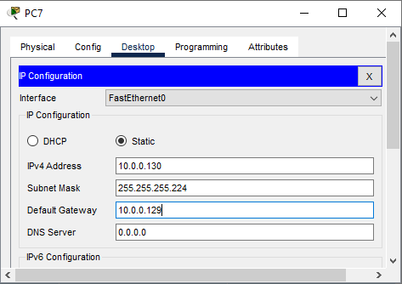
Step 1: Configure PCs with IPv4 addresses
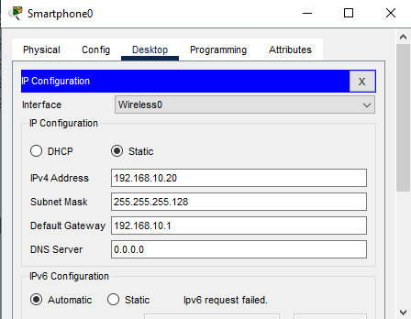
Use the addressing table to manually configure the PCs with full IP addressing.
manually as per above.
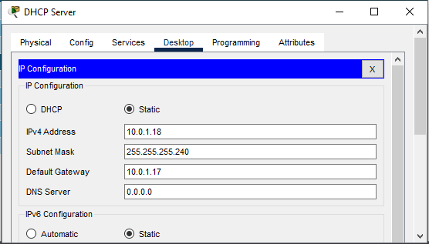

Step 2: Configure basic settings for each device.
a. Configure all Devices with the following:
R(Config)# no ip domain-lookup
2) Host name for all devices.
Router(config)#hostname router_name
3) Set the minimum password length to 10 characters.
R(Config)# Security passwords min-length 10
4) Use the MIU1234567 password for Console access password.
Router(config)#line con 0
Router(config-line)#login
Router(config-line)#password MIU1234567
5) Use the CSC1234567 secret password.
Router(config)#enable secret CSC1234567
6) Encrypt the clear text passwords.
R(Config)# service password-encryption

7) Configure an appropriate MOTD Banner.
Router(config)#banner motd “type message here”
b. Configure addressing for all devices according to the Addressing Table.
• Configuring IP addresses on the network devices (Routers, Switches, Layer 3 Switches).
• Assigning IP addresses to:
- Router interfaces (e.g., G0/0, G1/1)
- SVIs (Switched Virtual Interfaces on Layer 3 switches)
- L3 interfaces if using a multi-layer switch for inter-VLAN routing
- Configuring a Gigabit Ethernet Interface with IPv4:
Router(config)#interface gigabitethernet 0/0
Router(config-if)#description Accounting LAN
Router(config-if)#ip address 192.168.20.1 255.255.255.0
Router(config-if)#no shutdown
- Inter-VLAN Communication Using an External Router: Router-on-a-Stick:
Router(config)#interface gigabitethernet 0/0
Router(config-if)#no shutdown
Router(config-if)#exit
c. Configure SSH for all routers.
R(config) # ip domain-name cisco.com
R(config) # crypto key generate rsa press Enter 1024
R(config) # username Bop privilege 15 Secret Class or(R(config) # username Bop password Class)
R(config) # Line vty 0 4
R(config-line) # login local
R(config-line) # transport input ssh
R(config-line) # exit
Part 3:
Configure Network Infrastructure Settings (VLANs, Trunking, Inter-VLAN Routing
EtherChannel). (10%)
In this part, you will complete the Layer 2 network configuration and set up basic host support. At the end of this part, all the
switches should be able to communicate.
Step 1: Create VLANs on all switches.
S1(config)# vtp mode transparent
S1(config)# VLAN 2000
S1(config-vlan)# end
Step 2: On all switches, configure host access ports connecting to PCs.
  - Issue the show vlan brief command to verify VLAN configuration.
Switch(config)#interface range fastethernet 0/1 – 9
Switch(config-if-range)#switchport mode access
Switch(config-if-range)#switchport access vlan 10
Step 3: Configure an 802.1Q Trunk between the Switches
Switch(config)#interface fastethernet 0/1
Switch(config-if)#switchport mode trunk
Switch(config-if)#switchport trunk native VLAN 99
Switch(config-if)#switchport trunk allowed VLAN 10,20,30,99
Step 4: Configure Inter-VLAN Routing:
a. on the L3 Switches in the Main Branch:
§ On all L3 Switches, configure the interface connected to MIU-MIU-GW as a routed port and assign an IP
address according to the Addressing Table
§ Configure and activate the SVI interfaces for VLANs according to the Addressing Table

b. on the router in the MIU Branch:
§ Configure sub interfaces on Branch-GW router using the 802.1Q encapsulation.
- Set the encapsulation type to 802.1Q and assign VLAN 10 to the sub interface.
- Refer to the Address Table and assign the correct IP address to the sub interface.

Step 5: Verify Inter-VLAN Routing is working
Use ping trace route and arp table
Step 6: On all switches, create LACP EtherChannels as shown in the topology diagram.
S1(config)#interface range fastethernet 0/1 – 2
S1 (config-if)#channel-group 1 mode Active
S1 (config-if)#exit
• S1(config)#interface port-channel 1
S1(config-if)# Switchport mode Trunk
S1(config-if)# switchport trunk native vlan 999
S1(config-if)# switchport trunk allowed vlan 1,10,20
Step 7: Verify EtherChannels are working.
show vlan brief
show interfaces trunk
show etherchannel summary
show ip interface brief
ping [other device IP]

Part 4:
Configure Routing Protocols. (10%)
In this part, you will configure IPv4 routing protocols. At the end of this part, the network should be fully converged.
Step 1: Point-to-Point Single-Area OSPFv2 Configuration
- Start the OSPF routing process on MIU-GW router, Main-MLS, and S-MLS. Use process ID 100.
R2(config)#router ospf 100
- Configure Router IDs for three routers.
Router(config-router)# router-id rid
MIU-GW = 1.1.1.1
Main-MLS = 2.2.2.2
S-MLS = 3.3.3.3
- Configure Networks for OSPF Routing for three routers.
R2(config-router)# network interfaceIP 0.0.0.0 area 0
d. Configure Passive Interfaces to prevent the OSPF process from sending unnecessary routing protocol traffic out
LAN interfaces.
Router(configrouter)# passive-interface port

- Configure OSPF to propagate the default route in OSPF routing updates on MIU-GW router.
Router(config)#ip route 0.0.0.0 0.0.0.0 port
Router(config)#router ospf 100
Router(config-router)#defaultinformation originate
- Verify OSPF configuration. Use show commands to verify the network and passive interface configuration of the OSPF process on each router.
show ip ospf neighbor
• show ip ospf
• show ip ospf interface
• Show ip protocols
• show ip ospf interface brief
• show ip route ospf
• show ip ospf database
Step 2: Basic EIGRP with IPv4 Configuration
- Enable the EIGRP routing process on MIU-GW router, N-MLS, and R-MLS, using AS number 10.
conf t
router eigrp 10
no auto-summary
- Advertise directly connected networks on three routers.
router eigrp 10
network 192.168.1.0 0.0.0.255
network 10.1.1.0 0.0.0.255
- Configure the LAN interfaces to not advertise EIGRP updates.
router eigrp 10
passive-interface GigabitEthernet0/1
- Configure EIGRP to propagate the default route in OSPF routing updates on MIU-GW router.
ip route 0.0.0.0 0.0.0.0 <next-hop-ip>

router eigrp 10
redistribute static
- Verify EIGRP Routing
show ip eigrp neighbors
show ip route eigrp
show ip route
show ip protocols
Step 3: Configure Route Redistribution Between EIGRP and OSPF
- Configure Redistribution from OSPFv2 to EIGRP.
conf t
router eigrp 10
redistribute ospf 1 metric 10000 100 255 1 1500
- Configure Redistribution from EIGRP to OSPFv2.
router ospf 1
redistribute eigrp 10 subnets
- Verify OSPF, EIGRP, and redistribution settings.
show ip route eigrp
show ip protocols
show ip eigrp topology

show ip route ospf
show ip ospf
show ip ospf database

show run | section router
show ip protocols

Step 4: Configure IPv4 Static routing and Default Routes
- On MIU-GW and Branch_GW create IPv4 static default routes that point to ISP.
ip route 0.0.0.0 0.0.0.0 [Next-Hop-IP]
- On ISP, create IPv4 static routes that point to MIU-GW, Branch_GW, and Home Network.
ip route [Destination-Network] [Subnet-Mask] [Next-Hop-IP]

Part 5: Configure DHCP Server. (5%)
Step1: Configure DHCP Server on Main Branch
- Configure the excluded the first Three useable addresses from each address pool for VLANs: VLAN 5, VLAN 15, VLAN 130, and VLAN 35.
ip dhcp excluded-address 10.0.0.161 10.0.0.163
ip dhcp excluded-address 10.0.0.65 10.0.0.67
ip dhcp excluded-address 10.0.0.225 10.0.0.27
ip dhcp excluded-address 10.0.0.1 10.0.0.3
- Set the DHCP Server to assign IP address, DGW and DNS server for all Hosts in Main-Building and S-Building.
ip dhcp pool VLAN5
network 10.0.0.160 255.255.255.224
default-router 10.0.0.161
dns-server 10.0.1.21

ip dhcp pool VLAN15
network 10.0.0.64 255.255.255.192
default-router 10.0.0.65
dns-server 10.0.1.21

ip dhcp pool VLAN130
network 10.0.0.224 255.255.255.240
default-router 10.0.0.225
dns-server 10.0.1.21

ip dhcp pool VLAN35
network 10.0.0.0 255.255.255.192
default-router 10.0.0.1
dns-server 10.0.1.21

- Configure Main-MLS and S-MLS as a DHCP relay agent.
interface vlan 5
ip helper-address 10.0.1.18

interface vlan 15
ip helper-address 10.0.1.18

interface vlan 130
ip helper-address 10.0.1.18

interface vlan 35
ip helper-address 10.0.1.18

- Attempt to acquire an IP address from DHCP on PC1, PC2, PC3, PC4, PC5, and PC6.
On each PC:
- Set IP configuration to DHCP (Automatic).
- Use ipconfig (Windows) or equivalent to verify IP.
- Use ping to test gateway/DNS/internet.

Step2: Configure a Branch_GW Router as DHCP Server
  - Exclude the first five useable addresses from each address pool.
ip dhcp excluded-address 192.168.2.1 192.168.2.5
ip dhcp excluded-address 192.168.3.1 192.168.3.5
b. Create a DHCP pool named B-LAN2 for VLAN2 and B-LAN3 for VLAN3. (case-sensitive).
§ Configure the DHCP pool to include the network address, the default gateway, and the IP address of the DNS server.
ip dhcp pool B-LAN2
network 192.168.2.0 255.255.255.0
default-router 192.168.2.1
dns-server 10.0.1.21

ip dhcp pool B-LAN3
network 192.168.3.0 255.255.255.0
default-router 192.168.3.1
dns-server 10.0.1.21
c. Verify DHCP and Connectivity.
On PC11 (VLAN 2) and PC12 (VLAN 3):
- Set to DHCP.
- Run ipconfig or check IP settings.
- Test ping to:
  - Default gateway
  - Other PCs
  - Internet (if applicable)
Part 6: Configure Dynamic NAT with PAT and Static NAT. (5%)
Step 1: Configure Dynamic NAT with PAT on MIU-GW. The Public IP should use the third address from 209.165.200.224/28 address space.
Third Usable IP: 209.165.200.227
MIU-GW(config)# access-list 1 permit 10.0.0.0 0.255.255.255
MIU-GW(config)# ip nat pool publicPAT 209.165.200.227 209.165.200.227 netmask 255.255.255.240
MIU-GW(config)# ip nat inside source list 1 pool publicPAT overload
Step 2: Configure static NAT on MIU-GW to map the miu.edu.eg server inside address to the fourth address from the 209.165.200.224/28 address space.
Fourth Usable IP: 209.165.200.228
MIU-GW(config)# ip nat inside source static 10.0.1.20 209.165.200.228

Step 3: Configure the interfaces that will participate in NAT.
MIU-GW(config)# interface g0/0/0
MIU-GW(config-if)# ip nat inside
MIU-GW(config-if)# exit

MIU-GW(config)# interface g0/1/0
MIU-GW(config-if)# ip nat inside
MIU-GW(config-if)# exit

MIU-GW(config)# interface g0/2/0
MIU-GW(config-if)# ip nat inside
MIU-GW(config-if)# exit

MIU-GW(config)# interface g0/3/0
MIU-GW(config-if)# ip nat inside
MIU-GW(config-if)# exit

MIU-GW(config)# interface g0/1
MIU-GW(config-if)# ip nat inside
MIU-GW(config-if)# exit

MIU-GW(config)# interface g0/0
MIU-GW(config-if)# ip nat outside
MIU-GW(config-if)# exit

Step 4: Verify Dynamic NAT with PAT and static NAT Implementation.
MIU-GW# show ip nat translations
MIU-GW# show ip nat statistics
Step 5: Test Access with NAT and View NAT translations.

Part 7: Configure Network Management Features. (10%)
In this part, you will configure various network management features.
Step 1: Configure all devices. to use an NTP server.
configure terminal
ntp server 10.0.1.22
end
Router# show ntp status
Router# show association

Step 2: Configure and Verify Syslog on all devices.
configure terminal
logging host 10.0.1.22
logging trap debugging
logging on
end
show logging
Step 3: Web Server Configuration:
• Configure the web server to display the website's main page with the MIU logo.
Configure the Web Server (10.0.1.20):
Click on the Web Server device
Go to the "Services" tab
Select "HTTP" service
Turn the service ON
In the "HTML Code" section, replace the default code with:
<html>
<head><title>MIU Website</title></head>
<body>
<h1>Welcome to MIU</h1>
<img src="/miu-logo.png" alt="MIU Logo">
</body>
</html>
Go to the "File" tab and upload an image named "miu-logo.png"
• Ensure that the domain name for the website is miu.edu.eg.
- On the same server, go to the "DNS" service
- Add a new record:
  - Name: miu.edu.eg
  - Address: 10.0.1.20
  - Type: A Record
- Add another record:
  - Name: www
  - Address: 10.0.1.20
  - Type: CNAME Record
Step 4: Email Server Configuration:
• Configure the email server properly to support sending and receiving emails via the domain miu.edu.eg.
- Configure the Email Server (10.0.1.19):
  - Click on the Email Server device
  - Go to the "Services" tab
  - Select "EMAIL" service
  - Configure domain: miu.edu.eg
  - Create user accounts (e.g., "admin", "user1") with passwords
  - Turn the service ON
- Configure DNS for Email:
  - On the DNS server (10.0.1.21), add these records:
    - Name: mail.miu.edu.eg

Step 5: DNS Server Configuration:
• Configure the DNS server to resolve the domain name miu.edu.eg to the correct IP addresses for both the web server.
- Configure the DNS Server (10.0.1.21):
  - Click on the DNS Server device
  - Go to the "Services" tab
  - Select "DNS" service
  - Turn the service ON
  - Add these records:
    - Name: miu.edu.eg → 10.0.1.20 (A Record)
    - Name: www → miu.edu.eg (CNAME Record)
    - Name: mail → 10.0.1.19 (A Record)
      - Name: ns1 → 10.0.1.21 (A Record)

Part 8: Configure and Verify a Site-to-Site IPsec VPN. (10%)
Step 1: Verify connectivity throughout the network.
from MIU-GW to Branch_GW Public IP:
On MIU-GW: ping 64.100.1.0 (This is Branch_GW's public IP on the ISP side)
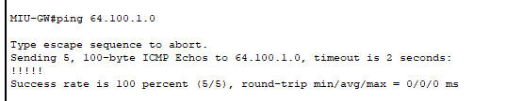
On MIU-GW: ping 209.165.200.226 (This is MIU-GW's public IP on the ISP side from Branch_GW's perspective).
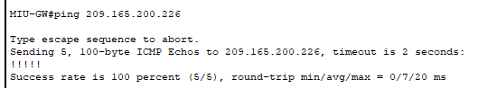
Ping from MIU Internal Network to Branch Internal Network (e.g., from R-Building PC9 to PC11):
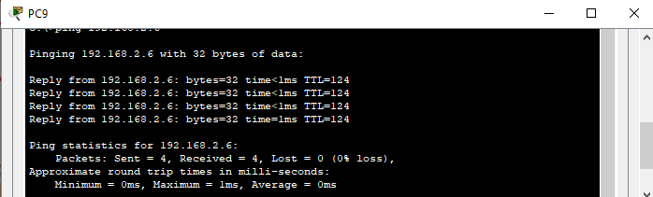
On a device in Branch VLAN2 (PC11): ping 10.0.0.164 PC1:

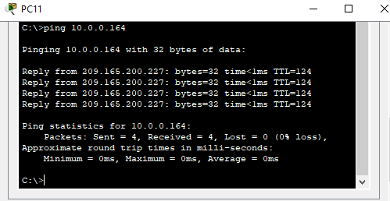

Verify Routing Tables:
show ip route on MIU-GW and Branch_GW to ensure they have routes to their respective internal networks and the ISP.
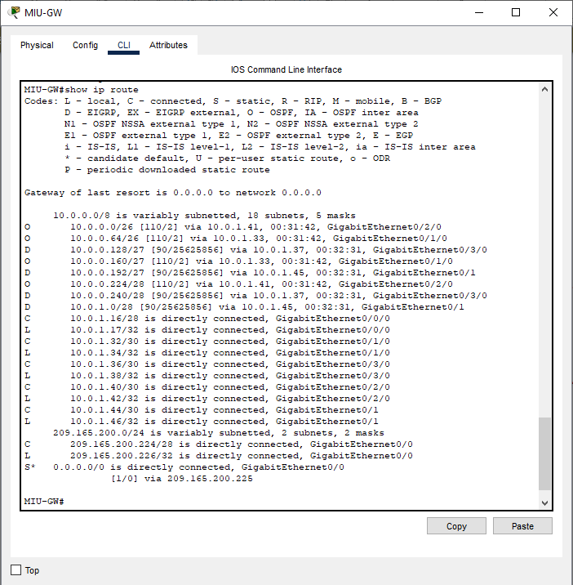
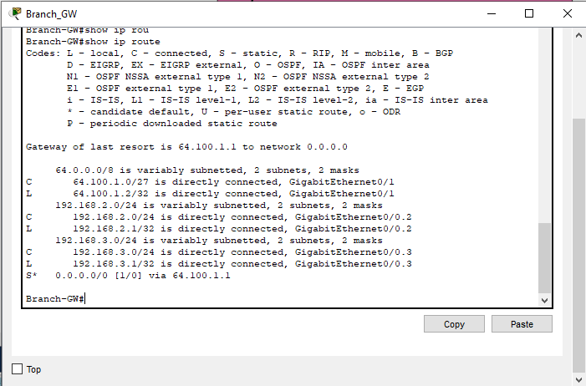

Step 2: Configure MIU-GW to support a site-to-site IPsec VPN with Branch_GW.
MIU-GW(config)# crypto isakmp policy 10
MIU-GW(config-isakmp)# encryption aes
MIU-GW(config-isakmp)# hash sha
MIU-GW(config-isakmp)# authentication pre-share
MIU-GW(config-isakmp)# group 2
MIU-GW(config-isakmp)# exit
MIU-GW(config)# crypto isakmp key CSC123 address 64.100.1.2

Branch_GW(config)# crypto isakmp policy 10
Branch_GW(config-isakmp)# authentication pre-share
Branch_GW(config-isakmp)# encryption aes
Branch_GW(config-isakmp)# hash sha
Branch_GW(config-isakmp)# group 2
Branch_GW(config-isakmp)# exit
Branch_GW(config)# crypto isakmp key myVPNkey address 209.165.200.226

MIU-GW(config)# crypto ipsec transform-set myTransformSet esp-aes esp-sha-hmac
MIU-GW(config)# ip access-list extended myTransformVPN
MIU-GW(config-ext-nacl)# permit ip 10.0.0.0 0.255.255.255 192.168.2.0 0.0.0.255
MIU-GW(config-ext-nacl)# permit ip 10.0.0.0 0.255.255.255 192.168.3.0 0.0.0.255
MIU-GW(config-ext-nacl)# exit
MIU-GW(config)# crypto map myMap 10 ipsec-isakmp
MIU-GW(config-crypto-map)# set peer 64.100.1.2
MIU-GW(config-crypto-map)# set transform-set myTransformSet
MIU-GW(config-crypto-map)# match address myTransformVPN
MIU-GW(config-crypto-map)# exit

Branch_GW(config)# crypto ipsec transform-set myTransformSet esp-aes esp-md5-hmac
Branch_GW(config)# ip access-list extended myTransformVPN
Branch_GW(config-ext-nacl)# permit ip 192.168.2.0 0.0.0.255 10.0.0.0 0.255.255.255
Branch_GW(config-ext-nacl)# permit ip 192.168.3.0 0.0.0.255 10.0.0.0 0.255.255.255
Branch_GW(config-ext-nacl)# exit
Branch_GW(config)# crypto map myMap 10 ipsec-isakmp
Branch_GW(config-crypto-map)# set peer 209.165.200.226
Branch_GW(config-crypto-map)# set transform-set myTransformSet
Branch_GW(config-crypto-map)# match address myTransformVPN
Branch_GW(config-crypto-map)# exit

Step 4: Verification Commands
show crypto isakmp sa
show crypto ipsec sa
show crypto engine connections active
Test connectivity through the VPN:
ping 192.168.50.1 source 10.0.1.1

Part 9: Configure a Wireless Home Router. (10%)
Step 1: Connect to a wireless router

Step 2: Configure the wireless router

§ Configure the WR SSID.

§ Change Network Name (SSID) to MIU-CSC230 for only 2.4 GHz. Notice that SSIDs are case-sensitive.

§ Configure wireless security settings.

§ Under the 2.4 GHz heading, select WPA2 Personal for the Security Mode.

§ For the Encryption field, keep the default AES setting.

§ In the Passphrase field, enter miu_csc230 as the passphrase.
Step 3: Connect the Wireless Clients and test the connectivity.

Part 10: Verify Connectivity. (10%)
Verify connectivity between all devices.
§ Perform a ping test between all devices connected to the network.
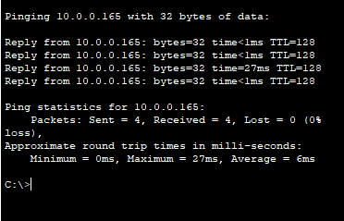
§ Take a screenshot of each ping operation.
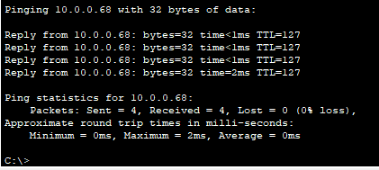
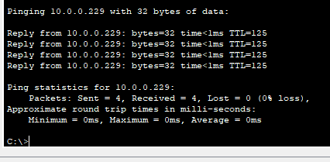
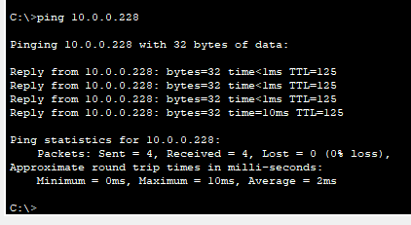
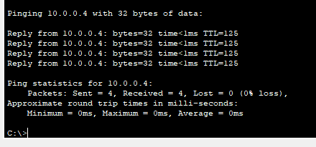
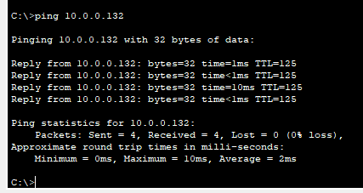
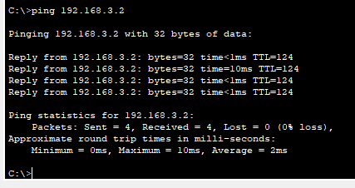
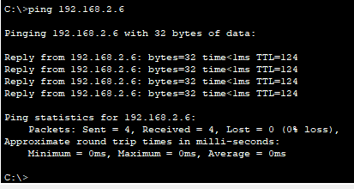
§ Display the IP address of each interface (IP Interface) on each device.
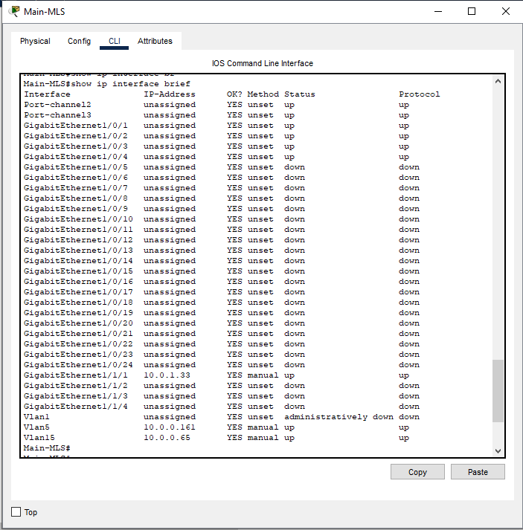
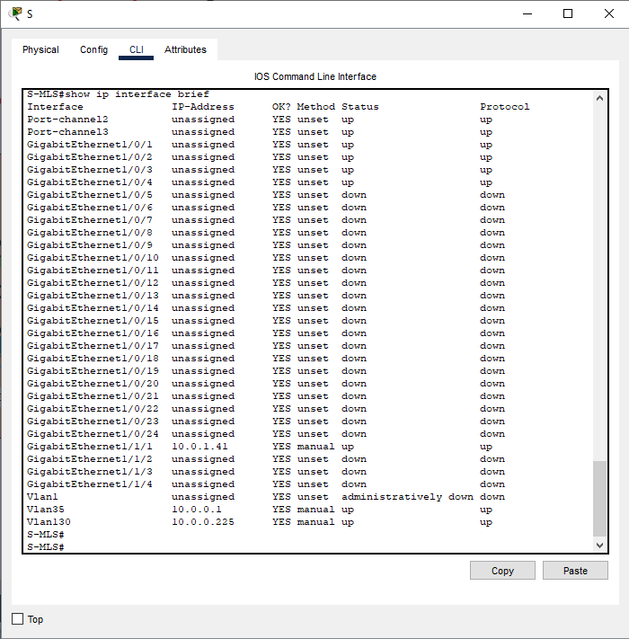
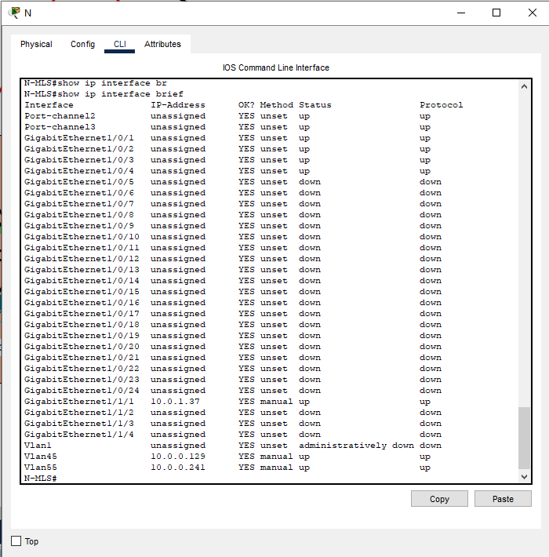
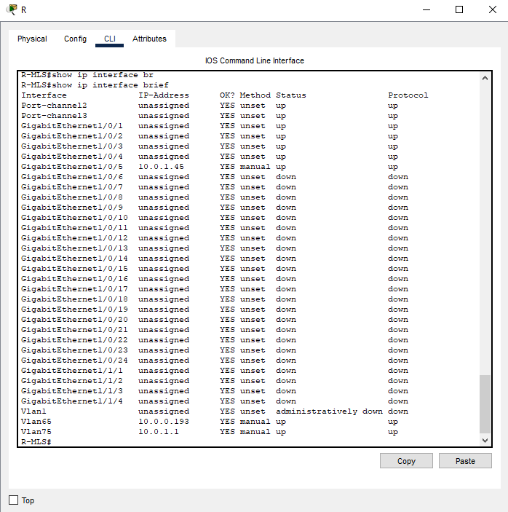
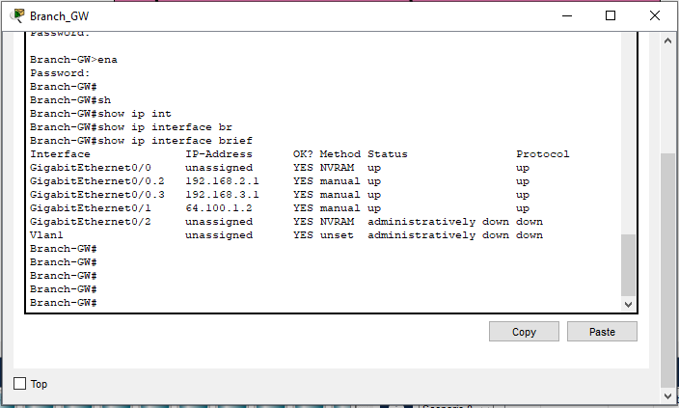
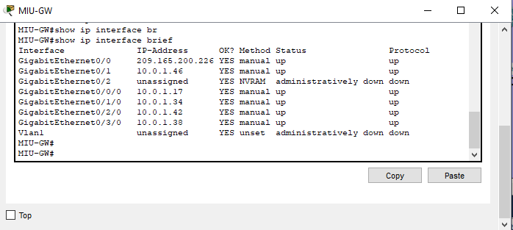
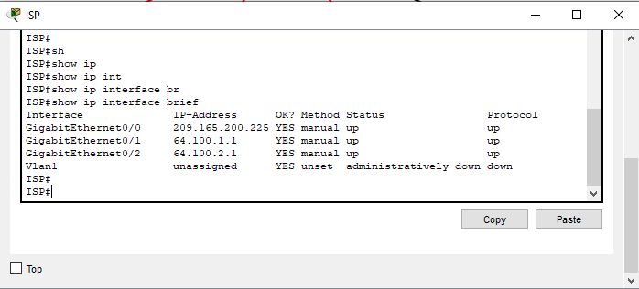
§ Display the routing table for each router in the network.
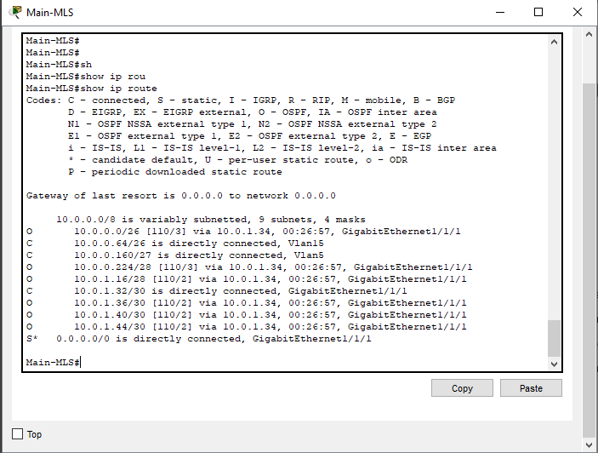
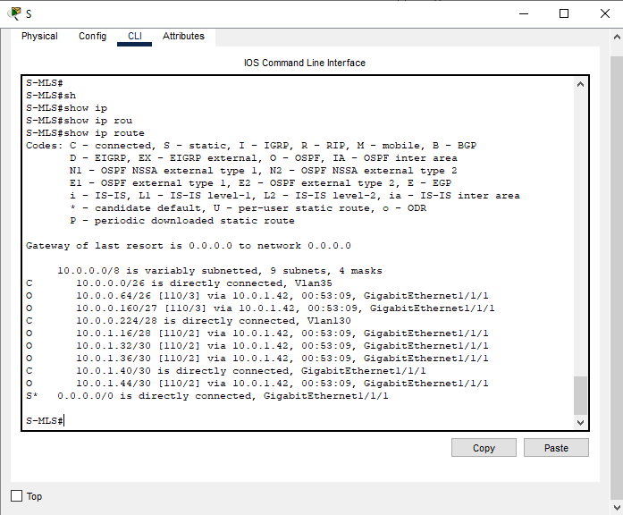
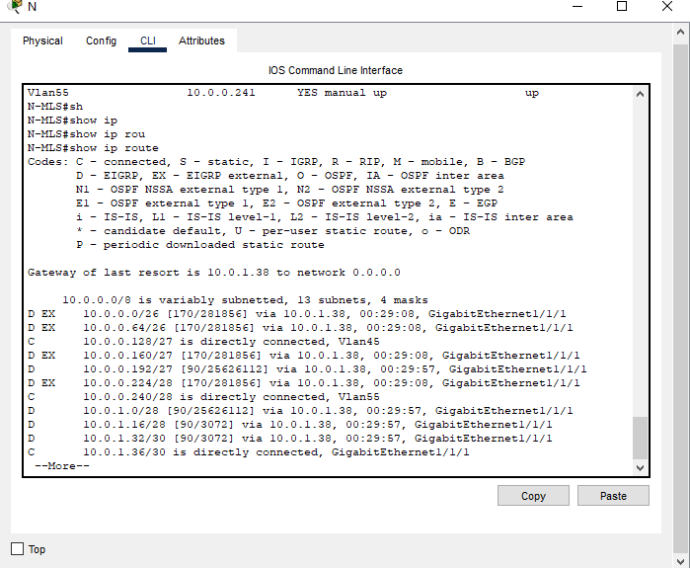
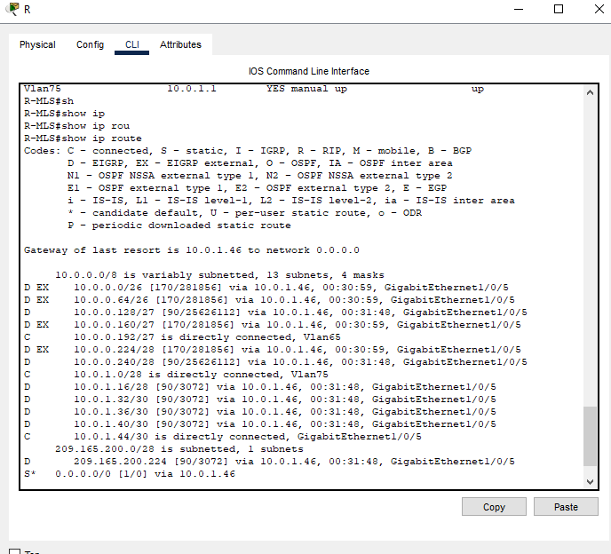
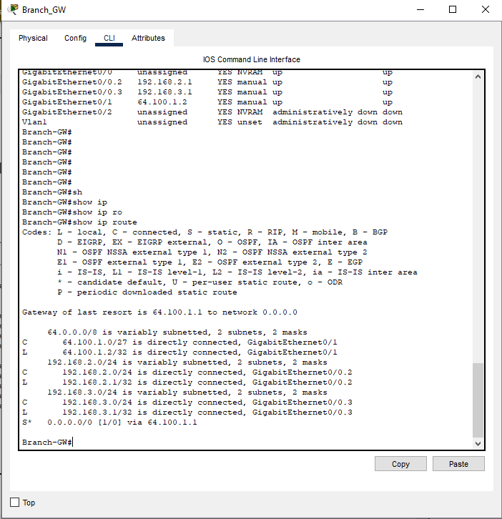
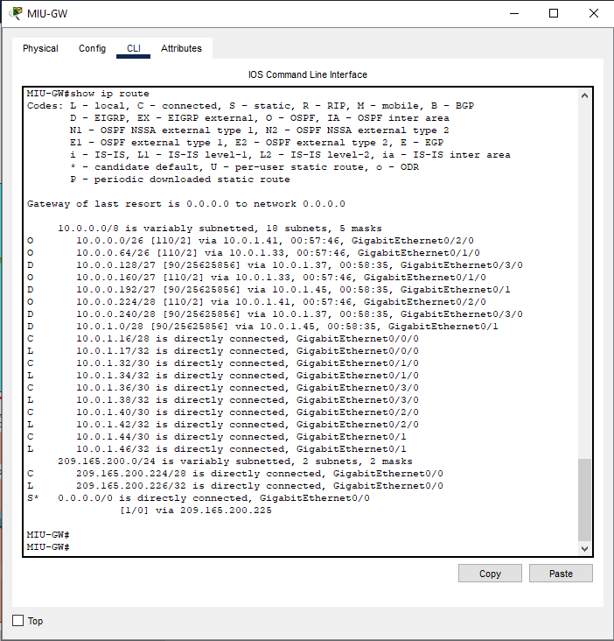
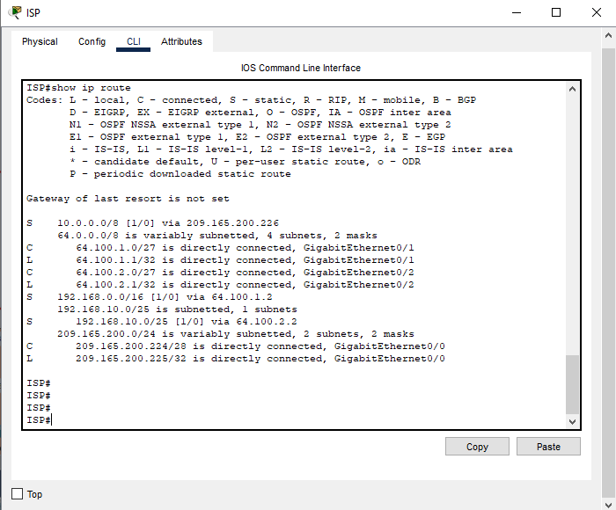
§ Add all the information and screenshots to the documentation.
Part 11: Documentation and Handover. (10%)
- Prepare a final document, either in .docx or PPT format, with detailed configurations for each part of the implementation.
- If you face any issues, provide the troubleshooting guide that you follow to detect and resolve that issue in any step. (Optional)
- Include testing screenshots for the ping command and traceroute command on different PCs.
- Include the IP routing table for each device after testing is done and the routing is built dynamically.

